Stream Study and Presentations Pictures

October, 2011

Environmental Science Class – Gahanna Lincoln

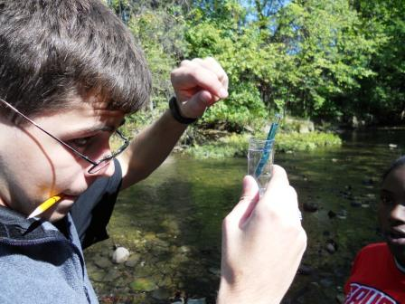

Student checking DO with kit

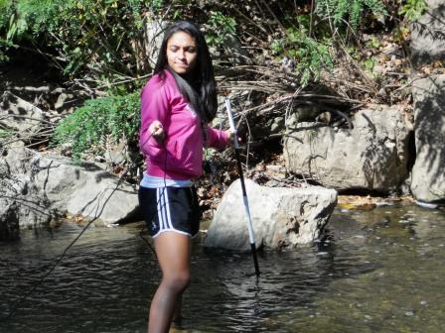

Student measuring stream velocity with Vernier Probe

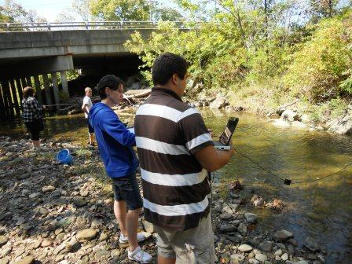

Student reading Vernier Probe results

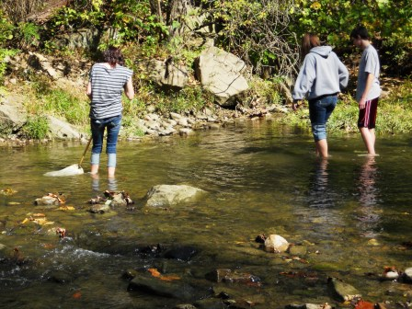

Students collecting critters in the run

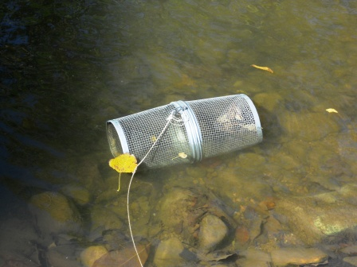

Trap set for fish collection has some samples!

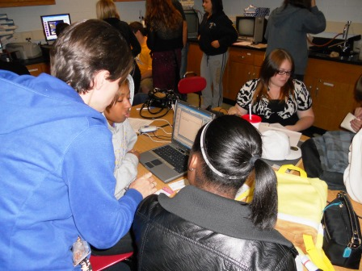

Teams organizing data from field

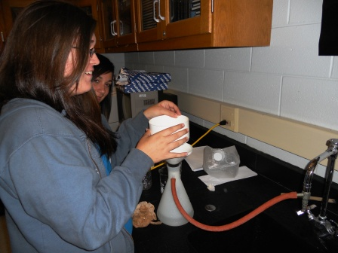

Filtering for Total Suspended Solids

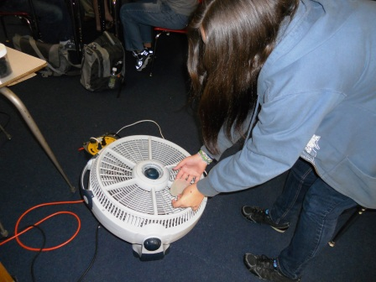

Drying TSS sample before weighing

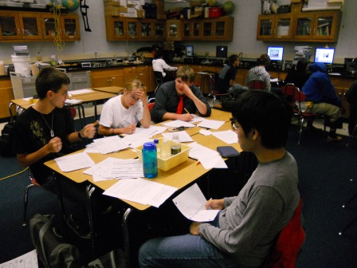

This data doesn’t make sense!!

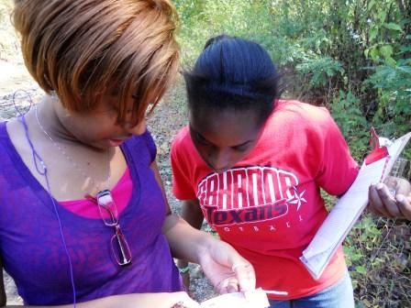

Checking keys for macro-invertebrate identification

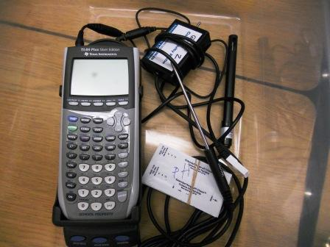 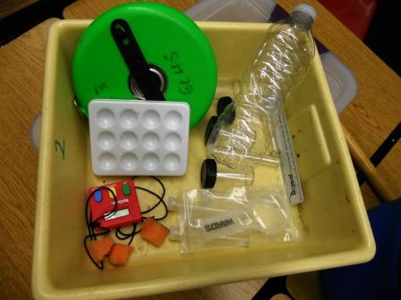

Equipment packed and ready for field

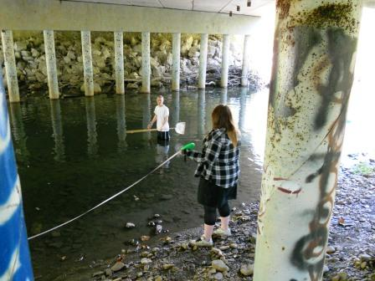

Measuring velocity the old fashioned way …

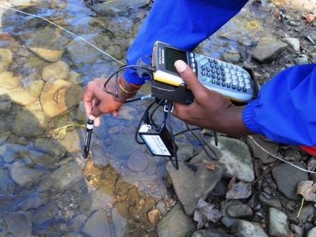

Checking conductivity for TDS

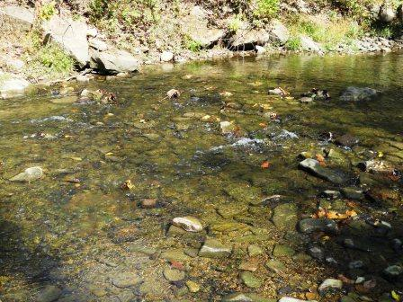

One of the riffle sections of our reach

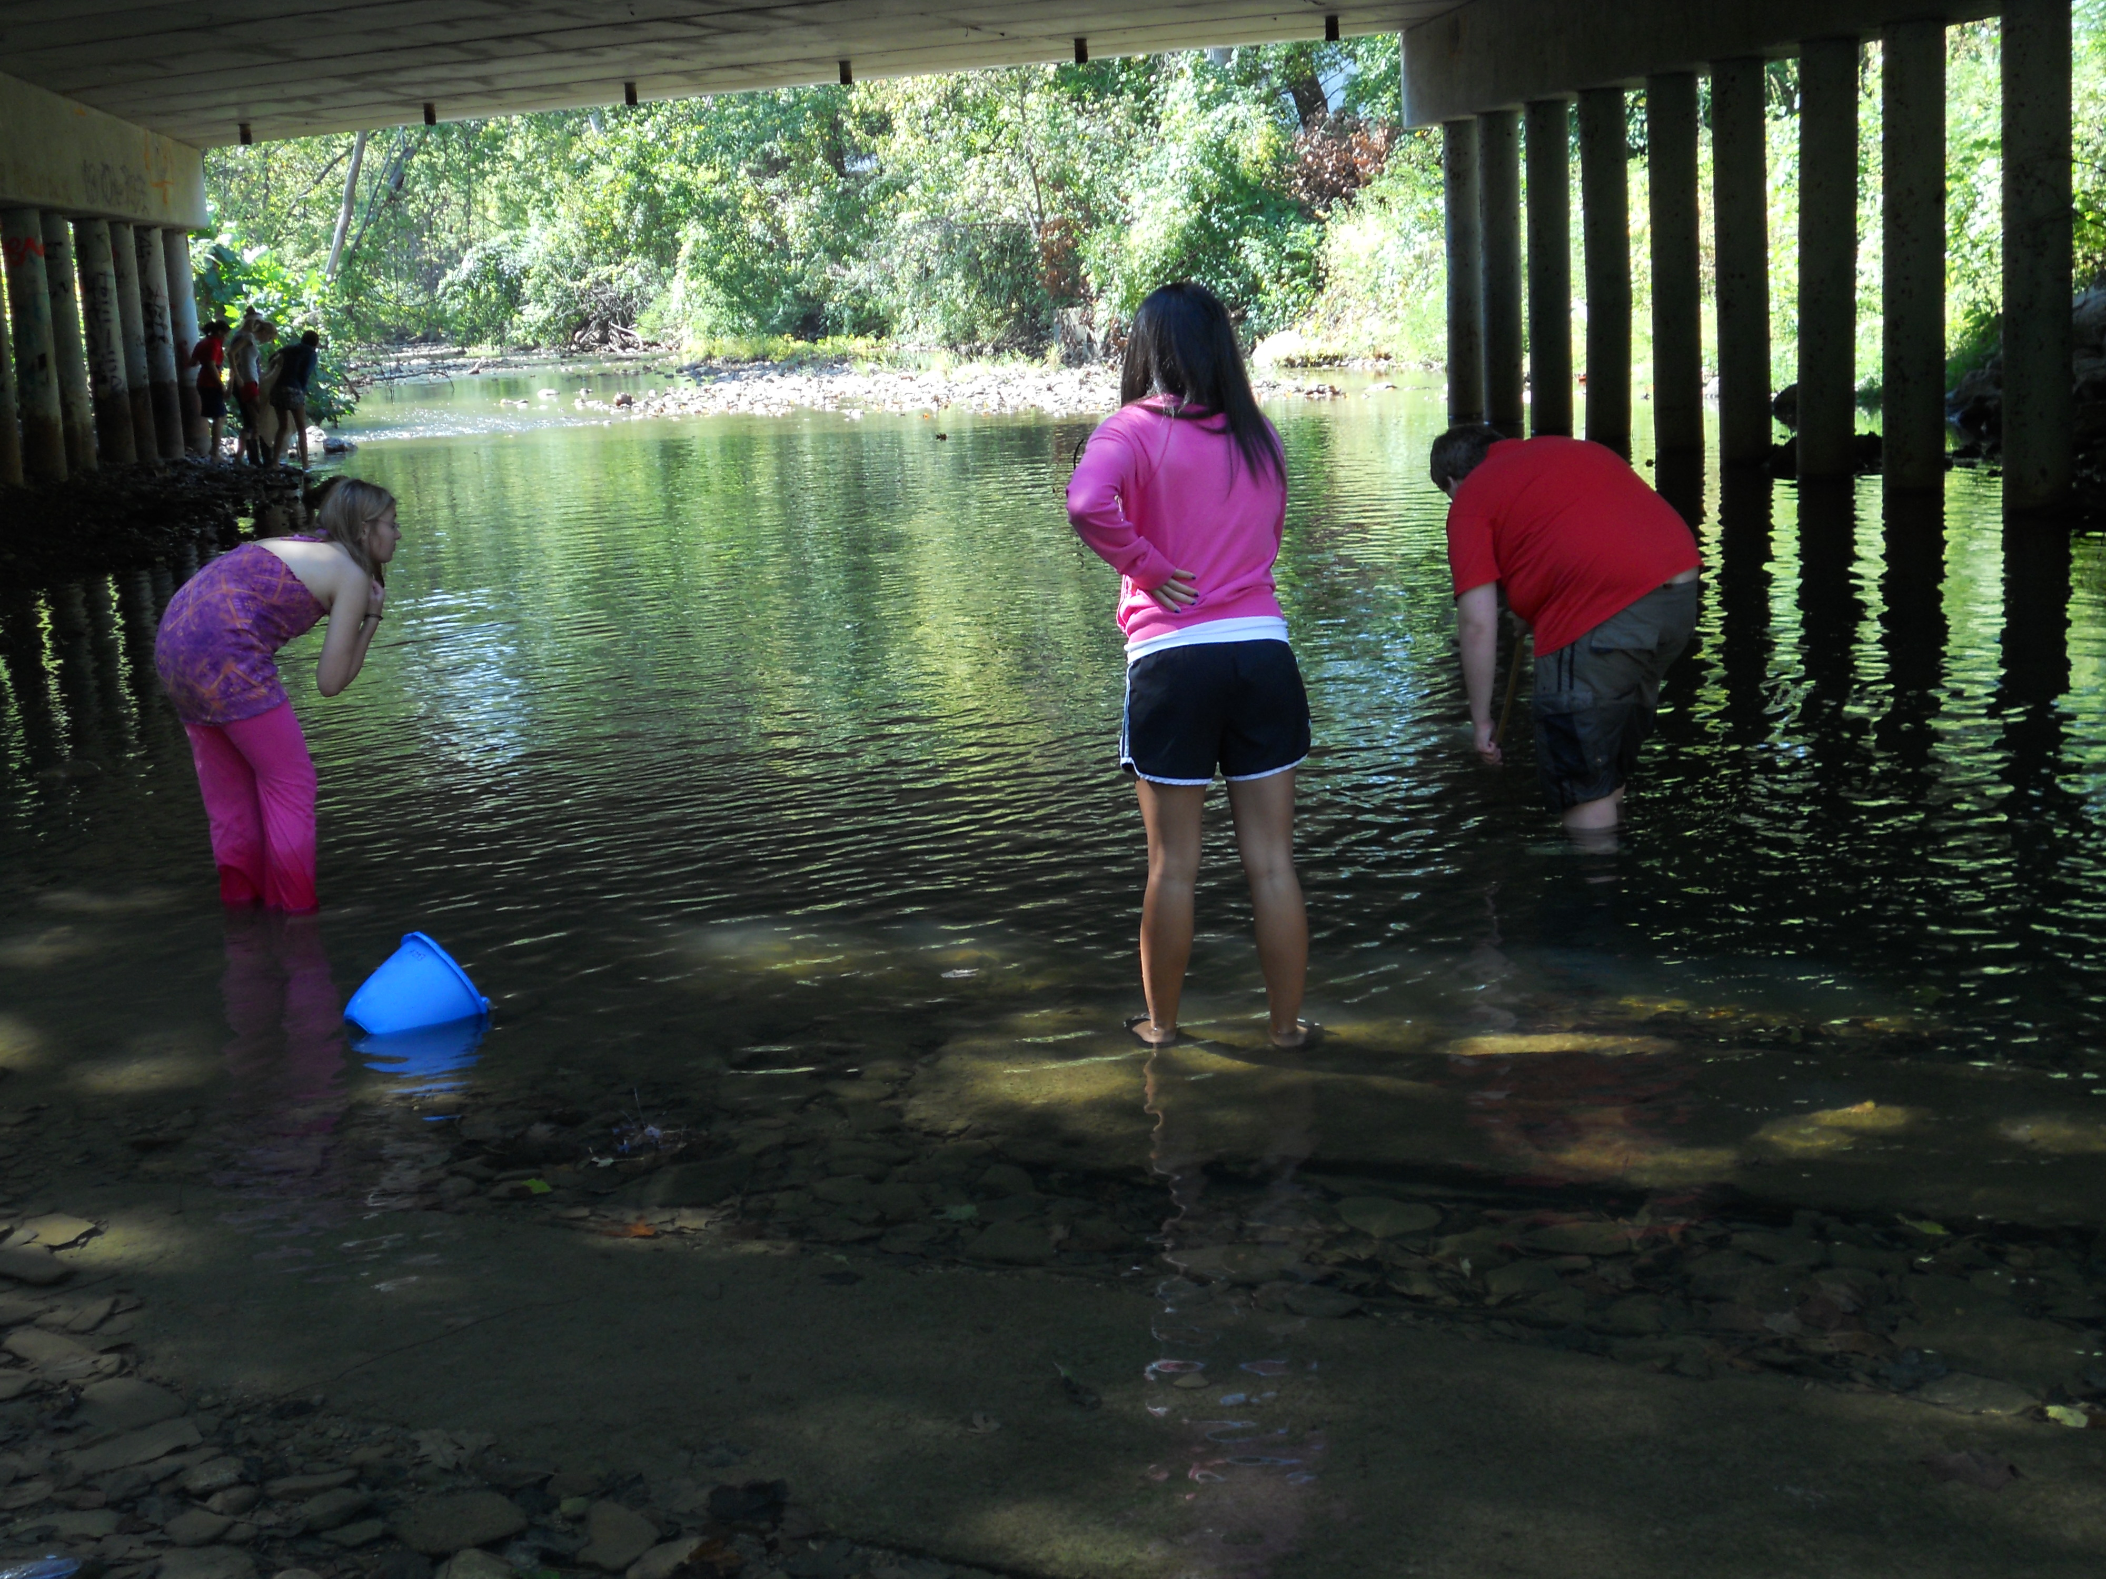

Collecting from the pool under the bridge